**Name : اسماء ايمن نصر الدين على يوسف**

**B.N: 188**

**Date : 31\5\2020**

**Topic: programming languages**

**Github link :**

**Github page :**

**Application brief :**

In the programming process, special languages ​​known as programming languages ​​are used, and these languages ​​carry vocabulary in addition to specific rules to guide the computer system to carry out specific tasks. Each programming language contains a set of special words in addition to a specific method of writing, which specifies how program orders are organized. One of the types of programming languages: html ,c, c ++, java, python, etc. I chose this topic because of its importance in many fields and I also prefer programming languages.

Some applications:

* Programming definition programs
* Video games
* Artificial intelligence
* programming languages used
* Databases

**Source code:**

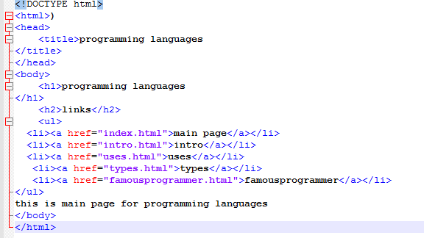

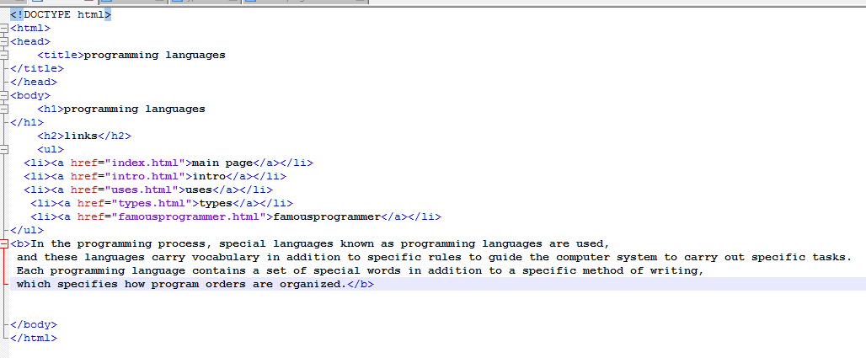

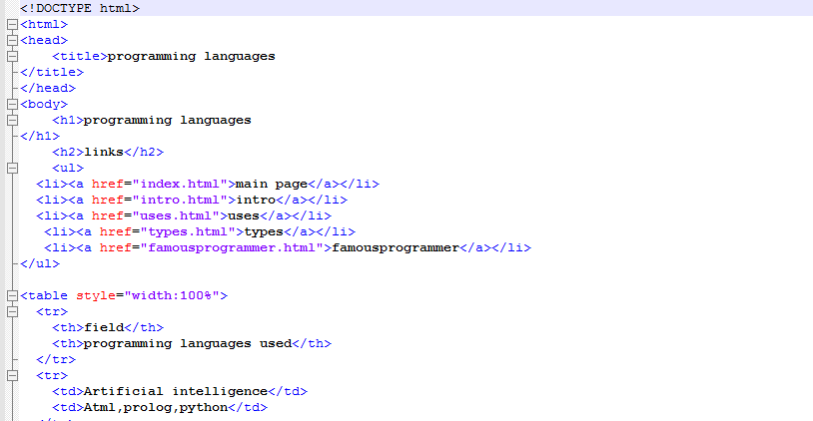

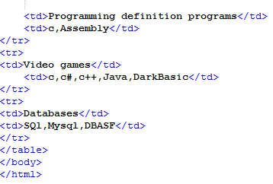

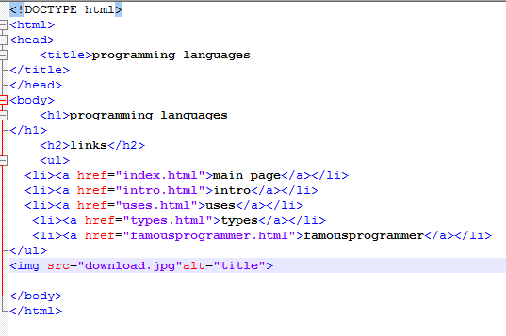

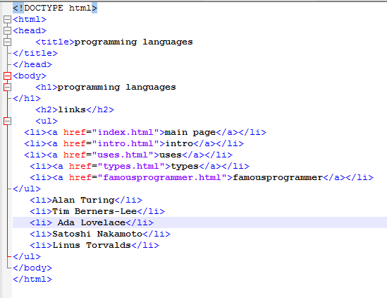

**Screeshot:**

